Goals and Tasks

# Background and Motivation

Valérie works as a defence scientist for Defence R&D Canada and is the Canadian representative on the NATO Research Task Group IST-141 Exploratory Visual Analytics. Through her work, she was exposed to a dataset and presentation about the Ukraine Improvised Explosive Devices (IED) situation produced by the NATO Counter-IED Center of Excellence (NATO C-IED COE) which is an International Military Organization, multinationally manned and funded by contributions from 9 sponsoring NATO nations (<http://www.coec-ied.es/>). Figures 1 and 2 below show current static visualization employed by the C-IED COE to visualize this data.



*Figure 1: Map of Ukraine IED incidents in 2014-2015.*

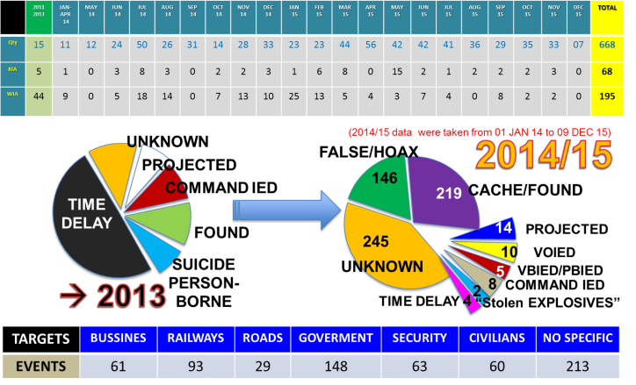

*Figure 2: Statistical data about Ukraine IED incidents in 2014-2015.*

Valérie, Marius and Shivas agreed that these visualizations could be improved upon using what they learned in the CS171 Visualization class. They decided to take the challenge of creating an interactive visualization for this data. The dataset is interesting because it contains many datatypes (quantitative, geographical, temporal, textual) and it can be augmented using additional data from the web. We intend to share the end result of our project with the NATO C-IED COE.

# Project Objectives and Goals

This project will allow the exploration of over 600 Improvised Explosive Devices incidents in Ukraine mostly over the past 2 years for the purpose of better understanding the temporal and geographical patterns in that data. We will also consider additional census data to uncover potential regional patterns. We intend to employ interactive visualization to generate better insights about the Ukraine IED situation.

# Questions

Here are some questions our project should help answer:

* Is there a temporal pattern in the number of IED incidents?
* Where are the IED incidents located within Ukraine?
* Do the ratios of incidents remain stable over time between the different regions? Do the incidents seem to move from one region to another?
* Do the different types of incidents have interesting geo-temporal patterns?
* Do the different types of IEDs have interesting geo-temporal patterns?
* Is the number of incidents correlated with regional census data, more specifically:
  + Are there less or more incidents in Russian speaking regions?
  + Are there less or more incidents in poorer regions?